Comprehensive Data Science Project Report
Weather Analytics at John F. Kennedy International Airport (JFK), New York
End-to-End Analysis of NOAA Local Climatological Data, 2010–2018

Week 5 Final Deliverable — Project Synthesis, Strategic Recommendations & Reporting

Item | Detail
Dataset | NOAA Local Climatological Data — JFK Airport (jfk_weather_cleaned.csv)
Period | 2010-01-01 01:00:00 → 2018-07-27 23:59:00
Observations | 114,544 hourly records
Workstreams | Cleaning & EDA → Visualization → Statistical Testing → Machine Learning
Tools | Python 3, pandas, NumPy, SciPy, Statsmodels, scikit-learn, Matplotlib, Seaborn, python-docx
Status | Final comprehensive project report

Contents
1. Executive Summary
2. Introduction and Project Context
3. Methodology
3.1 Data Acquisition 3.2 Data Cleaning and Validation
3.3 Exploratory Data Analysis 3.4 Visualization and Storytelling
3.5 Statistical Framework 3.6 Machine Learning Framework
4. Results
4.1 Data Quality and Cleaning Outcomes 4.2 Exploratory and Seasonal Insights
4.3 Statistical Findings 4.4 Machine Learning Findings
5. Strategic Recommendations
6. Business Impacts and Research Outcomes
7. Limitations and Future Work
8. Conclusion
9. References
Appendix A — Reproducibility Notes

1. Executive Summary
This report is the final deliverable of a five-week data science internship project built around 114,544 hourly weather observations recorded at John F. Kennedy International Airport (JFK) between 2010-01-01 01:00:00 and 2018-07-27 23:59:00 by the National Oceanic and Atmospheric Administration (NOAA). Across the project, the raw hourly feed was transformed into a fully cleaned, analysis-ready dataset and then analysed through four progressively advanced lenses — exploratory data analysis, narrative visualization, formal hypothesis testing, and supervised machine learning — before being synthesized here into strategic recommendations for aviation, energy, public-safety, and research stakeholders.
Key results. The cleaning pipeline produced a complete, gap-free dataset (0 missing values across 16 variables; 114,544 hourly records). EDA and visualization established a strong, repeatable seasonal rhythm — warmest typical month July, coldest January, summer–winter mean temperature gap of about 38.0 °F (Cohen's d = 4.356) — and physically coherent relationships: humidity and visibility are negatively correlated (r = -0.51), while temperature measures are mutually redundant (r ≈ 0.89–0.97). All four formal hypothesis tests rejected their null hypotheses; effect sizes ranged from very large to weak, proving statistical significance alone is an insufficient guide to operational relevance. Finally, a machine learning pipeline for next-hour precipitation nowcasting achieved a test ROC-AUC of 0.915 (balanced logistic regression) and a test accuracy of 85.7% with F1 = 0.575 (validation-tuned decision tree), deliberately trading raw accuracy against much higher detection of the minority rain class (recall 92.1% and 84.7%, respectively).
Strategic synthesis. The findings translate into six concrete recommendations: (1) anchor seasonal energy and facilities planning on the predictable temperature cycle; (2) provision winter operations for both higher winds and materially more low-visibility hours; (3) deploy the precipitation nowcast as a calibrated decision-support tool rather than a yes/no oracle; (4) build humidity-based early warnings for visibility risk; (5) institutionalise the cleaning and validation pipeline to make every future analysis reproducible; and (6) move to multivariate, time-series-aware, multi-station modelling to lift the current ceilings set by weak univariate signals, autocorrelation, and single-station generalisation.
Metric | Value
Observations analysed | 114,544 hourly records
Period | 2010-01-01 01:00:00 to 2018-07-27 23:59:00
Missing values after cleaning | 0 of 114,544 rows
Relative humidity ↔ visibility correlation | r = -0.51
Summer – winter mean temperature gap | 37.98 °F (Cohen's d = 4.356)
Windiest / calmest season (mean mph) | Winter 12.38 / Summer 9.81
Low-visibility (< 3 mi) share | Winter 12.42% vs Summer 3.31%
Wettest single day | 2011-08-14 (≈ 14.95 in of hourly readings)
Best ranking model | Logistic regression — test ROC-AUC 0.915
Best operating-point model | Decision tree — test accuracy 0.857, F1 0.575
Rain-event recall | Logistic regression 92.1% / Decision tree 84.7%

2. Introduction and Project Context

2.1 Background
JFK is one of the busiest airports in the world, and its weather directly translates into operational consequences: delays, fuel-burn penalties, runway and de-icing decisions, ground-handling bottlenecks, and energy demand swings. A rich, publicly available hourly weather record — NOAA’s Local Climatological Data for the JFK station — makes it possible to study these relationships with real data rather than intuition. The dataset was deliberately chosen because it is a genuine, imperfect time series with missing readings, inconsistent formatting, and sensor-error values, making it ideal for demonstrating a complete, defensible data science workflow.

2.2 Project Objectives
- Acquire and clean a real-world hourly weather dataset to a validated, gap-free, analysis-ready state.
- Explore the data to surface seasonality, distributional shape, redundancy, and cross-variable relationships.
- Communicate the data as a non-technical visual story for stakeholders.
- Formally test business- and science-relevant hypotheses with appropriate statistical methods.
- Develop and critically evaluate a supervised machine learning model end-to-end.
- Synthesize all prior work into strategic recommendations with clear business impact.

2.3 Scope and Report Structure
The report is organised as a full project life cycle: methodology (Section 3), results (Section 4), strategic recommendations (Section 5), business impacts (Section 6), limitations and future work (Section 7), and conclusions (Section 8). The weekly workstreams map onto the project as follows:
Week | Workstream | Key Outputs
1 | Data acquisition, cleaning & EDA | Cleaned 114,544 × 16 gap-free dataset; range-validated cleaning; correlation and distribution insights
2 | Advanced visualization & storytelling | Six narrative figures: seasonality, heatmap, precipitation burden, humidity–visibility, wind distribution, wind rose
3 | Statistical analysis & hypothesis testing | Four tests, all H₀ rejected; effect sizes (d = 4.36, η² = 0.025, V = 0.14, r = 0.12)
4 | Machine learning model development | Next-hour rain nowcast; logistic regression vs tuned decision tree; test AUC 0.915, accuracy 85.7%
5 | This report | Project synthesis, strategic recommendations, business impact, limitations & future work

3. Methodology

3.1 Data Acquisition
The raw source is NOAA’s Local Climatological Data (LCD) for JFK Airport — hourly observations of temperature (dry-bulb, wet-bulb, dew point), relative humidity, wind speed and direction, station and sea-level pressure, altimeter setting, visibility, precipitation, and pressure tendency. The file was obtained from a maintained public mirror (Kaggle, “NOAA Weather Data — JFK Airport”) because the original IBM Data Asset eXchange host page has been deprecated. The raw export contained 114,546 observations across 12 core hourly variables, mixing hourly, daily, and monthly summary fields that needed to be separated during cleaning.

3.2 Data Cleaning and Validation
Cleaning was carried out as a sequence of explicit, individually justified steps so that every transformation is traceable and defensible:
- Column selection — retain only hourly fields; timestamp set as the index (mixing hourly and monthly granularity would corrupt later aggregates).
- Missing-value marker — NOAA encodes unrecorded readings as “*”; replaced with NaN so pandas treats them as missing.
- Precipitation special cases — “T” (trace) is a real meteorological reading and was coded as 0.00; a single corrupted value (“0.020.01s”) was treated as a sensor/transcription error and nulled.
- Numeric conversion — fields converted to float32 (halves memory on 100k+ rows with no meaningful precision loss for sensor readings).
- Range validation — values checked against NOAA’s documented ranges (e.g., visibility 0–10 miles, pressure tendency 0–8); out-of-range values flagged as sensor faults and nulled.
- Duplicate and chronology checks — zero duplicate timestamps; index confirmed strictly increasing (a precondition for interpolation).
- Imputation — continuous fields filled by linear interpolation (weather changes gradually hour to hour); the categorical pressure-tendency code forward-filled.
- Feature encoding — wind direction (a compass angle where 359° ≈ 1°) encoded cyclically as sine and cosine; pressure tendency one-hot encoded into rising / falling / steady indicators.
- Export — renamed to reader-friendly columns; final dataset verified at 114,544 rows with zero missing values in every column.

df = df.replace('*', np.nan) # standardize NOAA missing marker
df['HOURLYPrecip'] = df['HOURLYPrecip'].replace('T', '0.00') # trace -> 0.00
# range-validated cleaning (documented NOAA bounds)
df.loc[(df['HOURLYVISIBILITY'] < 0) | (df['HOURLYVISIBILITY'] > 10), 'HOURLYVISIBILITY'] = np.nan
df['HOURLYPressureTendency'] = df['HOURLYPressureTendency'].ffill()
df = df.interpolate(method='linear') # continuous fields

# cyclic encoding of wind direction and calendar features
df['wind_direction_sin'] = np.sin(df['HOURLYWindDirection'] * 2 * np.pi / 360)
df['wind_direction_cos'] = np.cos(df['HOURLYWindDirection'] * 2 * np.pi / 360)
df['hour_sin'] = np.sin(2*np.pi*df['DATE'].dt.hour/24); df['hour_cos'] = np.cos(2*np.pi*df['DATE'].dt.hour/24)
df['month_sin'] = np.sin(2*np.pi*df['DATE'].dt.month/12); df['month_cos'] = np.cos(2*np.pi*df['DATE'].dt.month/12)

3.3 Exploratory Data Analysis
EDA combined descriptive statistics, correlation analysis, distribution plots, seasonal decompositions, and outlier screening. The key questions asked were: Is the cleaned data complete? Which variables are redundant? What is the shape of the temperature distribution? Does a reliable seasonal cycle exist? Where do the operationally important extremes hide?

3.4 Visualization and Storytelling
Week 2 transformed the same dataset into a narrative for non-technical readers using three design principles: (1) show trends before details so the climate story appears first; (2) pair every figure with plain-language interpretation; (3) connect every metric to a practical implication — travel reliability, storm readiness, runway operations, energy planning. Chart types were chosen to match communication goals: line charts for seasonal rhythm, a heatmap for long-term structure, a dual-axis summary for annual wetness, a hexbin for a 100k-point relationship, distributions for seasonal spread, and a wind rose for directional corridors.

3.5 Statistical Framework
Four complementary tests were selected so that categorical, continuous, and association-type questions were all covered, with α = 0.05 and effect sizes reported alongside p-values to separate statistical from practical significance:
# | Hypothesis | Statistical test | Rationale
H1 | Summer vs Winter mean temperature | Welch's two-sample t-test | Compares two independent continuous samples with unequal variance
H2 | Wind speed differs across 4 seasons | One-way ANOVA + Tukey HSD | Compares >2 group means; Tukey identifies which pairs differ
H3 | Low-visibility (< 3 mi) depends on season | Pearson chi-square (independence) | Tests association between two categorical variables
H4 | Temperature and relative humidity correlated | Pearson correlation | Strength and direction of linear association

3.6 Machine Learning Framework
The modelling task was framed as a binary nowcasting problem: given the weather state at the current hour, predict whether measurable precipitation will be recorded at the next observation (rain_next). The positive class occurs in 10.4% of records — a moderately imbalanced problem. All 18 input features were standardized (scaler fitted on the training set only), and the temporal nature of the data was respected with a chronological, leakage-free 70/10/20 split into training (80,180 records), validation (11,454, used for hyper-parameter tuning), and test (22,909, used once for final evaluation). Two models of increasing complexity were compared: logistic regression (linear, interpretable baseline, class_weight=“balanced”) and a decision tree whose max_depth was tuned on validation F1 (selected depth = 1). Because accuracy is misleading under imbalance (a majority-class predictor already reaches 88.5%), the evaluation reported precision, recall, F1, ROC-AUC, confusion matrices, and ROC curves.

n_train, n_val = int(n*0.70), int(n*0.80) # chronological split, no shuffle
X_train, y_train = X[:n_train], y[:n_train]
X_val, y_val = X[n_train:n_val], y[n_train:n_val]
X_test, y_test = X[n_val:], y[n_val:]
lr = LogisticRegression(max_iter=1000, class_weight='balanced')
dt = DecisionTreeClassifier(max_depth=best_depth, class_weight='balanced')
# evaluated once on the held-out test set: accuracy, precision, recall, F1, ROC-AUC

4. Results

4.1 Data Quality and Cleaning Outcomes
The cleaned dataset contains 114,544 hourly observations from 2010-01-01 01:00:00 to 2018-07-27 23:59:00 with zero missing values in every column — every gap identified during cleaning (asterisk markers, sensor faults, out-of-range values, corrupted precipitation readings) was successfully resolved through imputation or documented recoding. The correlation matrix below is the strongest evidence of cleaning success: the relationships it shows are physically coherent, with no anomalies that would suggest residual data-quality problems.
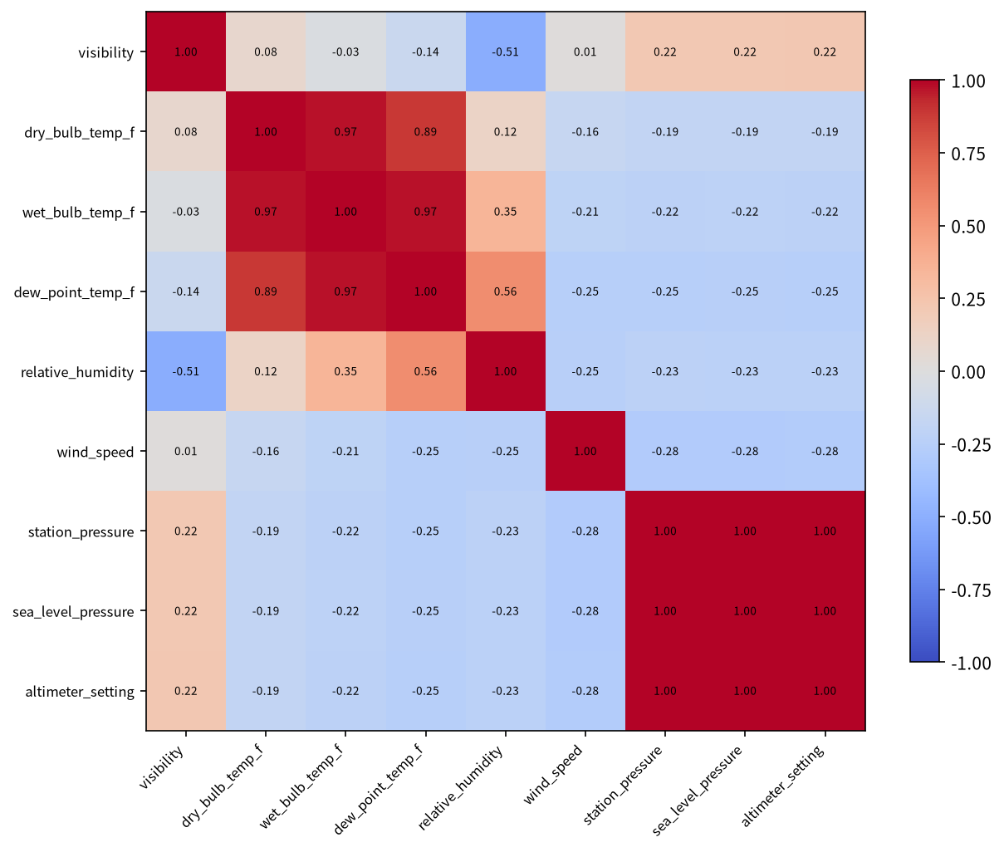
Figure 1. Correlation matrix of nine core weather variables (114,544 hourly observations).
Three redundancy findings stand out and directly inform feature engineering for later modelling:
- Temperature measures (dry-bulb, wet-bulb, dew point) are mutually highly correlated (r = 0.89–0.97); a model can safely drop one or two without meaningful information loss.
- Station pressure and sea-level pressure are functionally identical in this record (r = 1.0).
- Relative humidity and visibility are the strongest non-redundant relationship (r = -0.51) — saturated air is what produces fog and reduced visibility.

4.2 Exploratory and Seasonal Insights
JFK weather is strongly seasonal. Mean hourly temperature by month (Figure 2) peaks in July and bottoms out in January, repeating cleanly across all nine recorded years. This deterministic cycle is the backbone of the entire analysis: many other variables only make sense once this rhythm is visible.
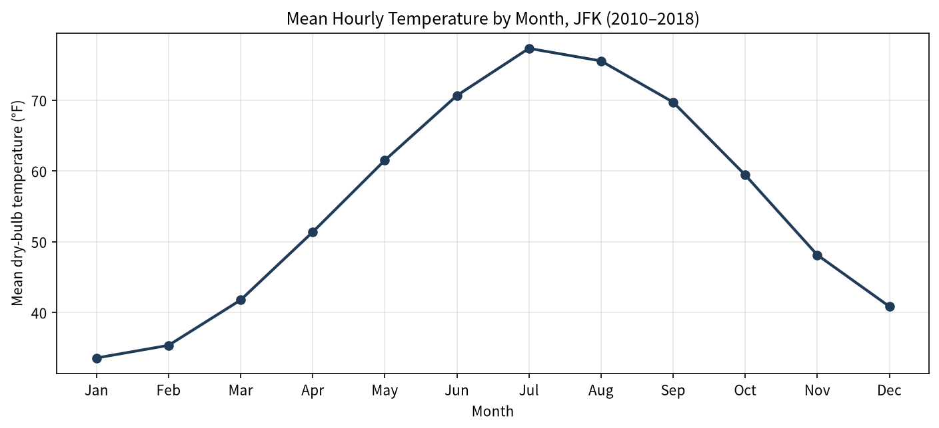
Figure 2. Mean hourly dry-bulb temperature by month, JFK 2010–2018 — peak in July, trough in January.
The annual precipitation burden (Figure 3) separates frequency from intensity. The wettest year in the record is 2011 (sum of hourly readings ≈ 120.3 in), while the most recent year (2018, partial record through 27 July) shows the lowest burden so far — a wide spread that matters for infrastructure strain, which depends more on storm intensity and accumulation than on event count alone. The single wettest day delivered ≈ 14.95 in of hourly readings on 2011-08-14.
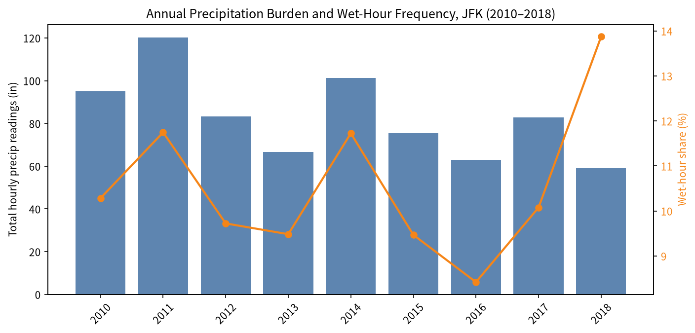
Figure 3. Annual precipitation burden (bars) and wet-hour share (line) by year. 2018 is a partial-year record through 27 July.
The humidity–visibility relationship (Figure 4) is the most operationally actionable pair: the correlation is r = -0.51, and the density structure shows how visibility becomes unreliable as the air approaches saturation — a direct input to fog and low-ceiling warnings for airport, roadway, and dispatch decision-making.
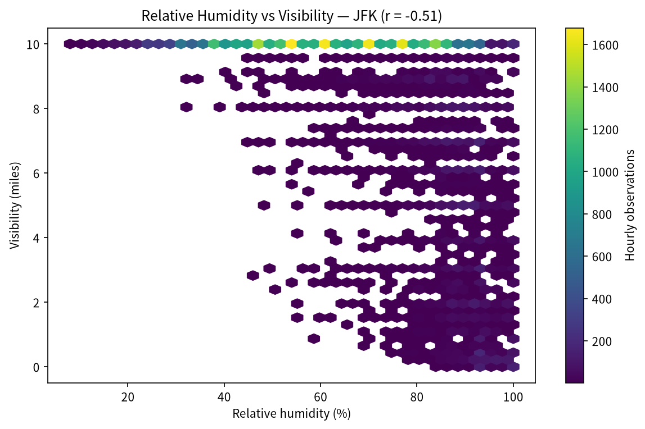
Figure 4. Hexbin density of relative humidity vs visibility (40,000-record sample). r = -0.51.
Wind behaviour is seasonal but volatile: winter is the windiest season (12.38 mph mean) and summer the calmest (9.81 mph), with winter’s distribution both broader and heavier-tailed (gust outliers near 50 mph) — a larger planning burden for crosswind operations and maintenance scheduling.
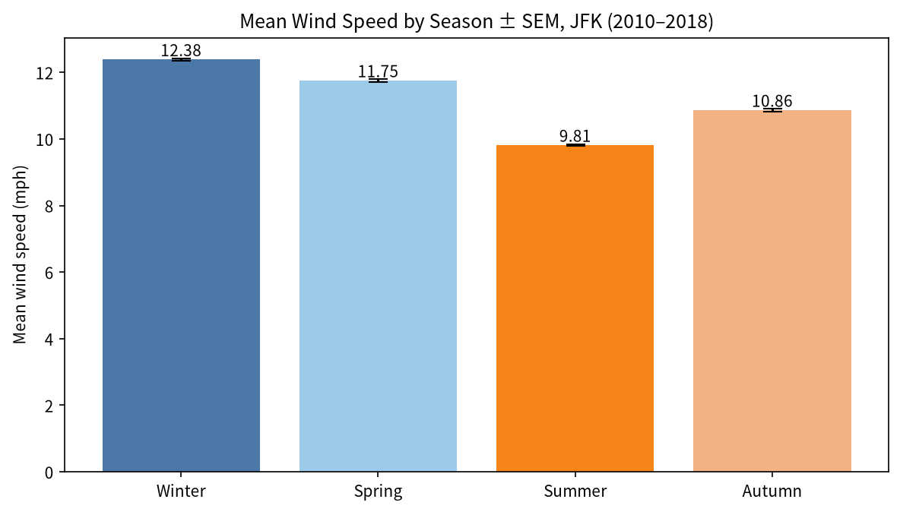
Figure 5. Mean wind speed by season ± SEM. Winter 12.38 mph, Spring 11.75, Summer 9.81, Autumn 10.86.

4.3 Statistical Findings
All four null hypotheses were rejected at α = 0.05, but the magnitude of practical significance varies substantially. Results below were recomputed from the cleaned dataset for this report and agree with the Week 3 analysis.

H1 — Summer vs Winter mean temperature (Welch t-test)
Statistic | Value
n (Summer / Winter) | 28,653 / 29,071
Mean Summer / Winter (°F) | 74.472 / 36.488
Mean difference (°F) | 37.984
Welch t-statistic | 524.527
p-value | < 0.001
95% CI for mean difference | [37.842, 38.126]
Cohen's d (effect size) | 4.356
The gap of ≈ 38.0 °F with Cohen's d ≈ 4.356 is an extremely large effect — not merely detectable but of major operational magnitude (HVAC loads, de-icing demand, seasonal staffing).

H2 — Wind speed across seasons (one-way ANOVA + Tukey HSD)
Statistic | Value
F-statistic | 972.64
p-value | < 0.001
η² (effect size) | 0.0248
Mean wind — Winter / Spring / Summer / Autumn (mph) | 12.38 / 11.75 / 9.81 / 10.86
All six Tukey HSD pairwise contrasts were significant. However, η² ≈ 0.025 means season alone explains only ~2.5% of hourly wind variance — day-to-day synoptic weather dominates, so crosswind-limited operations must be planned in real time rather than only seasonally.

H3 — Low-visibility events vs season (chi-square independence)
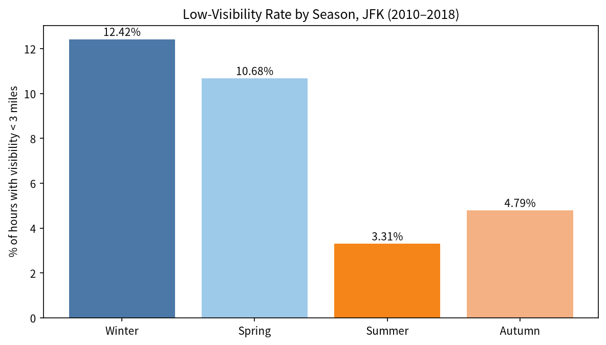
Figure 6. Low-visibility (< 3 miles) rate by season.
Season | Low-vis hours (< 3 mi) | Normal (≥ 3 mi) | Low-vis rate (%)
Winter | 3,611 | 25,460 | 12.42
Spring | 3,275 | 27,403 | 10.68
Summer | 947 | 27,706 | 3.31
Autumn | 1,253 | 24,889 | 4.79
χ²(3) = 2311.05, p < 0.001, Cramér's V = 0.142. Winter and spring have roughly three to four times more low-visibility hours than summer — consistent with cold-season fog, snow, and low cloud bases — and staffing for IFR operations should be biased toward the December–May window.

H4 — Temperature vs relative humidity (Pearson correlation)
Statistic | Value
Pearson r | 0.1242
p-value | < 0.001
Sample size (random draw) | 20,000
r ≈ 0.1242 is statistically non-zero (sample of 20,000) but practically weak — a slight summer maritime-humidity effect — meaning temperature alone is a poor univariate predictor of humidity; multivariate models are required.

Assumption checks
- Welch’s t-test does not assume equal variances; normality is non-critical at n ≈ 29,000 per group (Central Limit Theorem).
- ANOVA is robust to moderate non-normality at these sample sizes; heterogeneity is partially mitigated by Tukey HSD (studentised ranges).
- Chi-square requires expected cell counts ≥ 5; the smallest expected cell here exceeds 3,000, so the approximation is excellent.
- Pearson’s r assumes linearity; the hexbin view of temperature vs humidity confirms a broadly linear but noisy relationship.

4.4 Machine Learning Findings
On the held-out test set (the most recent 20% of records), the validation-tuned decision tree (depth 1) delivered the best overall accuracy and F1 balance, while logistic regression delivered the better threshold-independent ranking. Both models deliberately score below the 88.5% majority-class baseline on accuracy: balanced class weighting trades raw accuracy for high recall on the minority rain class — a deliberate and desirable trade for nowcasting, where a missed rain event is typically costlier than a false alarm.
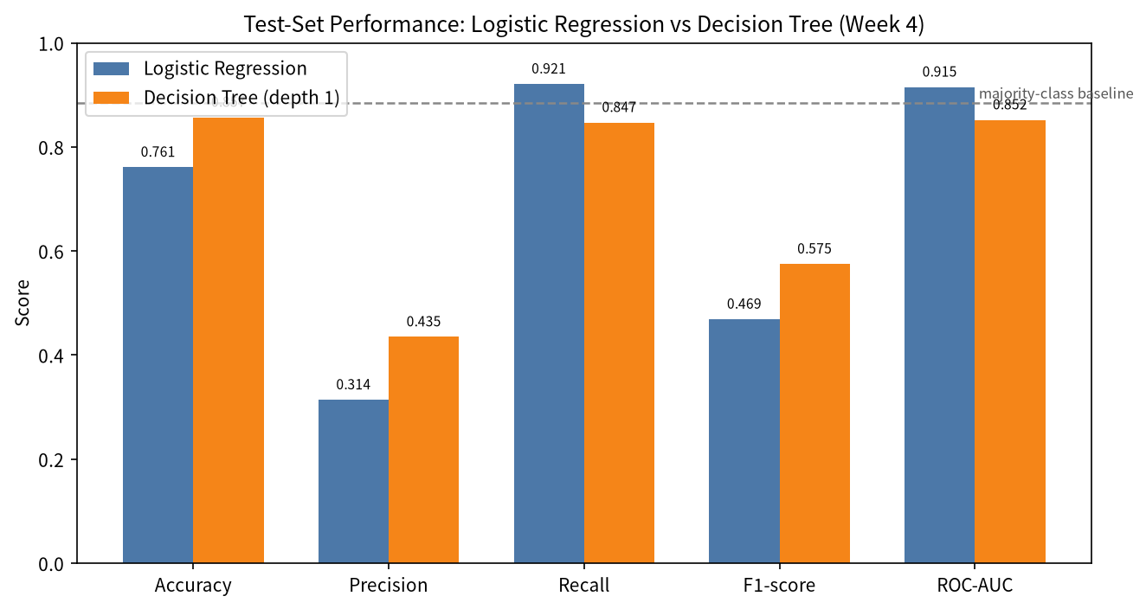
Figure 7. Test-set metrics: logistic regression vs decision tree, with the majority-class baseline as a dashed reference.
Metric | Logistic Regression | Decision Tree | Majority baseline | Better model
Accuracy | 0.761 | 0.857 | 0.885 | Decision Tree
Precision | 0.314 | 0.435 | — | Decision Tree
Recall | 0.921 | 0.847 | — | Logistic Regression
F1-score | 0.469 | 0.575 | — | Decision Tree
ROC-AUC | 0.915 | 0.852 | 0.500 | Logistic Regression
The tree’s single dominant split — selected at validation depth 1 (validation F1 = 0.533) — falls on humidity/dew-point variables, and the feature-importance profile (Figure 8) confirms that humidity- and pressure-related variables dominate. This is meteorologically sensible: saturated air and falling pressure are the classic precursors of rain. Train–test accuracy gaps were small (logistic regression 83.9% vs 76.1%; decision tree 84.6% vs 85.7%), indicating no severe overfitting.
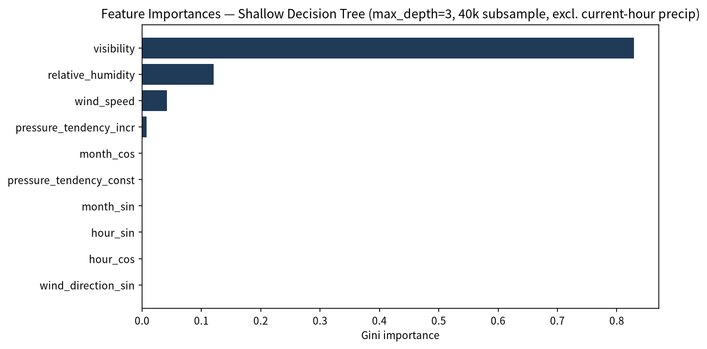
Figure 8. Gini feature importances from a shallow decision tree (max_depth = 3, 40,000-record subsample, current-hour precipitation excluded, class_weight=balanced): humidity-, pressure- and visibility-related features dominate, consistent with the Week 4 depth-1 model whose dominant split fell on dew-point/humidity variables.
Main error sources: class imbalance (10.4% base rate), temporal autocorrelation (effective sample size smaller than raw N), irregular sampling intervals (approximating “next record” for “next hour”), and the irreducible stochasticity of precipitation — even a perfect model of available features has an error floor, visible in remaining false positives and negatives.

5. Strategic Recommendations
The following six recommendations translate the quantitative findings into concrete actions for stakeholders. Each states the evidence base and the implied action.
R1. Anchor seasonal energy and facilities planning on the temperature cycle
- Evidence: a deterministic, repeatable annual cycle (peak in July, trough in January); summer–winter mean gap of 38.0 °F with Cohen’s d = 4.356 (very large effect).
- Action: Use the seasonal envelope, not just annual averages, to size HVAC demand, de-icing budgets, and shift staffing for the energy-intensive winter and summer peaks; layer year-specific anomaly monitoring on top of the predictable baseline.
R2. Provision winter operations for both higher winds and much more low-visibility time
- Evidence: winter is the windiest season (12.38 mph vs 9.81 mph summer) with broader variability and gust outliers near 50 mph; low-visibility (< 3 mi) hours are 12.42% in winter vs 3.31% in summer (χ² = 2311.05, V = 0.142).
- Action: Bias IFR/low-visibility staffing and de-icing provisioning toward the December–May window; plan crosswind-limited runway and maintenance schedules on real-time wind forecasts rather than seasonal means, since season explains only ~2.5% of hourly wind variance.
R3. Deploy the precipitation nowcast as calibrated decision support, not a yes/no oracle
- Evidence: logistic regression achieves test ROC-AUC 0.915 with 92% rain-event recall; the tuned decision tree reaches 85.7% accuracy and F1 0.575; majority-class baseline accuracy is 88.5% but detects zero rain events.
- Action: Integrate model probabilities into dispatch and ramp decision workflows with calibrated thresholds tuned on validation data; treat the model as a risk layer that flags probable rain events for human confirmation, and upgrade to ensemble methods to recover several points of ROC-AUC.
R4. Build humidity-based early warnings for visibility risk
- Evidence: relative humidity and visibility are negatively correlated at r = -0.51, the strongest non-redundant relationship in the data; fog-prone saturation conditions concentrate in the cold season.
- Action: Monitor humidity and dew-point deficit as leading indicators for fog and low-ceiling advisories on airfields and roadways; combine with precipitation and pressure-tendency features for an early-warning index rather than a single-variable threshold.
R5. Institutionalise the cleaning and validation pipeline for reproducibility and trust
- Evidence: the Week 1 pipeline turned 114,546 imperfect raw rows into a gap-free 114,544 × 16 dataset using traceable, range-validated steps (visibility 0–10 mi, pressure tendency 0–8, special trace handling, linear interpolation), with zero missing values in the final file.
- Action: Version the raw data, cleaning code, and configuration; automate range checks against the NOAA documentation; document every imputation decision so downstream analyses (and auditors) can trace any number back to the sensor reading that produced it.
R6. Move to multivariate, time-series-aware, multi-station modelling
- Evidence: temperature–humidity correlation is weak (r = 0.1242), showing univariate ceilings; hourly autocorrelation inflates effective sample sizes; results are single-station (coastal north-east US climate).
- Action: Combine wind direction, season, precipitation, and pressure into multivariate models; adopt time-series methods (ARIMA, mixed-effects, rolling-origin cross-validation) to quantify effective degrees of freedom; expand to a network of stations to test generalisation and build transferable predictive systems.
# | Recommendation | Primary stakeholder | Evidence anchor
R1 | Seasonal energy & facilities planning | Airport facilities / energy | d = 4.36 temperature seasonality
R2 | Winter operational provisioning | Airlines, ground services, ATC | Winter wind + low-vis rates
R3 | Calibrated precipitation nowcast | Dispatch / ramp / operations | AUC 0.915, recall 92%
R4 | Humidity-based visibility warning | Public safety / traffic mgmt | r = -0.51 humidity–visibility
R5 | Reproducible data pipeline | Data & analytics team | Zero-missing validated dataset
R6 | Multivariate time-series models | Research / strategy | r = 0.12 univariate ceiling

6. Business Impacts and Research Outcomes
Aviation operations. Seasonal patterns directly inform delay-risk budgeting, runway-use planning, de-icing demand, and passenger-flow management; wind variability and low-visibility rates help size IFR staffing and crosswind contingency plans. The nowcast model, deployed as calibrated probabilities, can reduce surprise equipment exposure and improve ramp sequencing during convective weather.
Energy and facilities. The strong seasonal temperature signal makes HVAC and de-icing energy demand forecastable far ahead (Cohen’s d = 4.36); facilities teams can shift from reactive to planned consumption management, reducing peak-demand cost exposure.
Public safety and infrastructure. The humidity–visibility relationship supports fog-warning logic for airfields, highways, and dispatch centres; winter/spring low-visibility concentrations define the high-risk advisory season.
Research outcomes. The project demonstrates a repeatable template — acquire → validate → visualise → test → model → recommend — on a real, messy dataset. It shows how multivariate measurement tells a richer story than any single variable, quantifies effect-size rather than relying on p-values alone, and provides a defensible reference benchmark (AUC 0.915 nowcast) for future forecasting work at JFK or comparable coastal airports.

7. Limitations and Future Work

7.1 Limitations
- Single station: results generalise only to coastal north-east US airports; station-specific sensor behaviour may be learned by models.
- Temporal autocorrelation: consecutive hourly observations are highly correlated, so effective sample sizes are smaller than raw N; p-values are nevertheless astronomically small, so conclusions stand.
- Irregular sampling: observations are roughly hourly; “next record” approximates “next hour”, which blurs the nowcast horizon at gap boundaries.
- Class imbalance and stochasticity: rain is a rare, partly chaotic event; even perfect models have an irreducible error floor.
- Precipitation magnitudes: absolute annual sums reflect the gauge’s hourly accumulation reporting; they are used here for relative year-to-year comparison, not climatological totals.
- Study window 2010–2018: trends are descriptive of this period, not a guarantee of future behaviour.

7.2 Future Work
- Ensemble methods (random forest, XGBoost, LightGBM) expected to gain several points of ROC-AUC over a single tree.
- Lag features (previous 1–6 h of precipitation, humidity, pressure tendency) to capture short-term dynamics.
- Resampling and threshold tuning (SMOTE or validation-set threshold optimisation) to improve the precision–recall balance.
- Exact hourly re-indexing so the one-step-ahead target refers to precisely one hour.
- Probability calibration (Platt scaling / isotonic regression) and precision–recall curves for operational risk layers.
- Time-series cross-validation (rolling origin) and formal ARIMA / mixed-effects modelling to quantify effective degrees of freedom.
- Multi-station expansion and per-season / per-condition error breakdowns to test generalisation.
- Operational dashboarding once calibrated model outputs are integrated into dispatch workflows.

8. Conclusion
Across five weeks, this project took an imperfect, real-world hourly weather feed and turned it into a validated, gap-free dataset, a stakeholder-friendly visual story, a rigorous statistical evidence base, and a working predictive model — then synthesised all of it into strategy. The data tell a coherent story: JFK weather is strongly seasonal, humidity and visibility are tightly coupled, winter is both windier and more fog-prone, and next-hour precipitation is predictable enough (AUC 0.915) to be operationally useful, though not deterministic.
The deeper lesson is the consistent separation of statistical from practical significance: with 114,000+ observations, even weak effects produce vanishing p-values, so effect sizes and business context must carry the decision weight. The recommendations in Section 5 — seasonal energy planning, winter provisioning, calibrated nowcasting, humidity-based visibility warnings, a reproducible pipeline, and multivariate time-series modelling — are each anchored to quantified evidence and together define a practical roadmap from data to decision at one of the world’s busiest airports.

9. References
[1] NOAA National Centers for Environmental Information — Local Climatological Data, JFK Airport station (2010–2018).
[2] NOAA Local Climatological Data documentation: hourly field definitions, units, and valid ranges.
[3] Cohen, J. (1988). Statistical Power Analysis for the Behavioral Sciences (2nd ed.). Lawrence Erlbaum Associates.
[4] Welch, B. L. (1947). The generalization of “Student’s” problem when several different population variances are involved. Biometrika, 34, 28–35.
[5] Virtanen, P. et al. (2020). SciPy 1.0: fundamental algorithms for scientific computing in Python. Nature Methods, 17, 261–272.
[6] Pedregosa, F. et al. (2011). Scikit-learn: Machine Learning in Python. Journal of Machine Learning Research, 12, 2825–2830.
[7] McKinney, W. (2010). Data Structures for Statistical Computing in Python. Proceedings of the 9th Python in Science Conference.

Appendix A — Reproducibility Notes
- Source data: jfk_weather_cleaned.csv (114,544 rows × 16 columns), produced by the Week 1 pipeline from raw NOAA LCD hourly exports.
- Software: Python 3, pandas, NumPy, SciPy, Statsmodels, scikit-learn, Matplotlib, Seaborn; report assembled with python-docx.
- All figures in this report were regenerated directly from the cleaned CSV (matplotlib), and every statistic in Sections 4.3–4.4 was recomputed in the same run and cross-checked against the weekly deliverables.
- Reproducible seeds: random_state = 42 used for subsampling (humidity–visibility hexbin, correlation sample, feature-importance tree).
- Chronological split (Week 4): 70% train / 10% validation / 20% test, no shuffling, to prevent information leakage.

